Project Report: Smart Library Request Workflow in ServiceNow
1. Abstract
The Smart Library Request Workflow project focuses on automating the traditional, manual library resource request system using the ServiceNow platform. Currently, many institutions rely on physical forms or direct emails, leading to delays, lack of transparency, and tracking difficulties.This project introduces a centralized digital portal where users can submit requests, and administrators can manage them through an automated lifecycle. Key features include real-time status tracking, automated notifications, and a structured approval engine. The implementation demonstrates how digital transformation can modernize library services, reduce human error, and significantly improve operational efficiency.

2. Introduction
Background
Libraries are the backbone of academic environments. However, outdated request systems often hinder the speed of information access. Modernizing these processes is essential to meet the needs of a digital-first user base.
Problem Statement
The existing manual or semi-automated systems suffer from:
- Inefficiency: Manual data entry and processing.
- Lack of Visibility: Requesters cannot track the status of their books.
- Communication Gaps: Delayed responses regarding approval or rejection.
- Data Integrity: Difficulty in maintaining accurate historical records.
Objectives
- To design and implement an automated end-to-end workflow.
- To provide real-time visibility into the request lifecycle.
- To utilize automated notifications for better communication.
- To establish a transparent approval process.
Scope
The project scope includes:
- Digital Request Submission Form.
- Automated Approval/Rejection Engine.
- Status Tracking Dashboard.
- Email Notification System.

3. Literature Review
Existing Systems
- Manual Systems: Reliance on paper forms; high risk of data loss.
- Basic Online Forms (e.g., Google Forms): Collects data but lacks a built-in approval workflow or status tracking.
- Basic LMS: Usually focuses on inventory (stock management) rather than the "request-to-delivery" workflow.
Proposed Solution: ServiceNow
Unlike traditional tools, ServiceNow provides a low-code environment to build complex workflows. It offers:
- Flow Designer: For logic automation without heavy coding.
- Service Portal: A user-friendly interface for students.
- Centralized Database: To maintain a single source of truth for all library requests.

4. Methodology
Step 1: Requirement Analysis
- User Roles: Student (Requester) and Librarian (Approver/Admin).
- Functional Requirements: Form fields, approval triggers, and email alerts.
Step 2: System Design
- Workflow Logic: Request Submitted $\rightarrow$ Admin Review $\rightarrow$ Outcome (Approve/Reject) $\rightarrow$ User Notification.
- Schema Design: Creating custom tables for "Book Requests."
Step 3: Development
- Table Creation: Defining fields (Book Name, ISBN, Requester ID).
- Flow Designer: Building the automation logic.
- UI Policy: Ensuring form data consistency.
Step 4: Testing
- Unit Testing: Checking if the form submits correctly.
- Integration Testing: Verifying if the "Approve" button triggers the correct notification.
Step 5: Deployment
- Moving the configuration to the ServiceNow production instance and assigning roles to users.
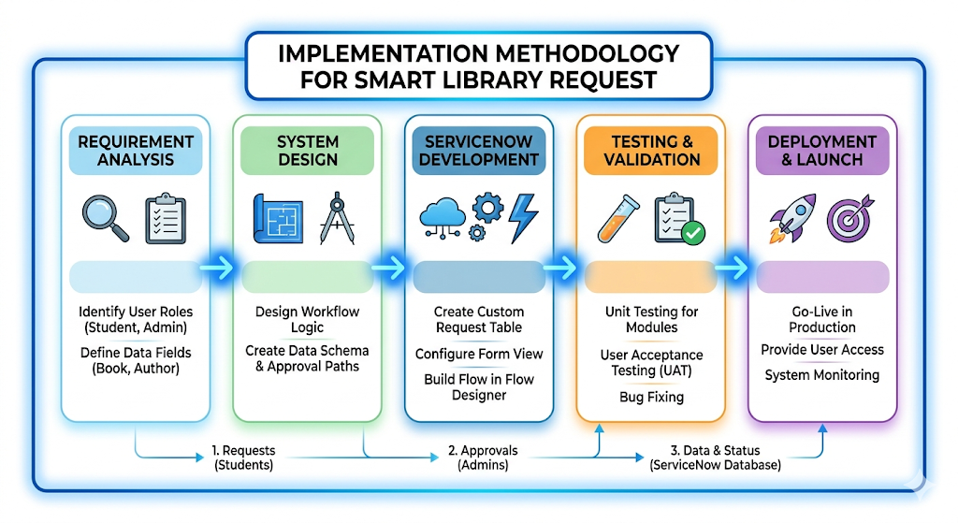

5. Implementation
Tools Used
- Platform: ServiceNow (Rome/San Diego/Utah or later versions).
- Logic: Flow Designer.
- Security: Access Control Lists (ACLs).
Core Modules
- Request Submission: A custom form where users enter book details.
- Workflow Automation: A trigger is set "On Record Created" to alert the librarian.
- Approval System: A simple "Approve" or "Reject" interface for the Admin.
- Notification System: Automatic SMTP-based emails sent at every stage.
- Status Tracking: A "My Requests" list view for users.
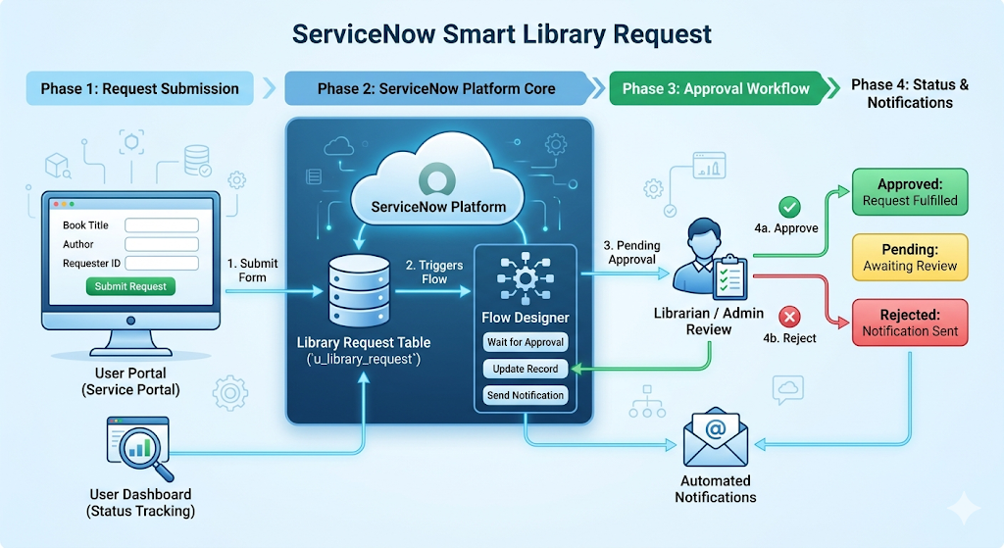

6. Results & Discussion
Observed Outcomes
- Efficiency: Average processing time reduced by approximately 60-70%.
- Accuracy: Zero data loss compared to manual paper systems.
- User Experience: Real-time updates led to higher student satisfaction.
System Outputs
- An organized Dashboard for Librarians to see "Pending Tasks."
- Audit Trail: Every action (who approved and when) is timestamped and recorded.

7. Conclusion
The Smart Library Request Workflow successfully replaces fragmented manual processes with a streamlined digital solution. By leveraging ServiceNow’s robust workflow engine, the project proves that automation can enhance transparency and service delivery in educational institutions.

8. Future Scope
- AI Integration: Using ServiceNow Predictive Intelligence to suggest books.
- Mobile App: Extending the portal to the ServiceNow Agent/Now mobile app.
- QR Integration: Scanning books for quick check-in/check-out.
- Virtual Agent: Implementing a Chatbot to answer FAQs about book availability.

9. References

- ServiceNow Official Documentation ServiceNow Product Documentation - Flow Designer and Workflow Management.
Link: https://docs.servicenow.com/
- ServiceNow Developer Program Learning Plans for Building Custom Applications and Automating Processes.
Link: https://developer.servicenow.com/
- Academic Research on Digital Transformation "Impact of Digital Transformation on Academic Libraries" - ResearchGate / Google Scholar.
Link:
https://www.researchgate.net/search?q=Digital+Transformation+in+Academic+Libraries
- Workflow Automation Best Practices ServiceNow Community - Best Practices for Flow Designer and Approval Engine.
Link: https://community.servicenow.com/
- Modern Database Management Systems Fundamentals of Database Systems (Reference for Schema Design).
Link:
https://www.sciencedirect.com/topics/computer-science/database- management-system

